Dracula

(1931)

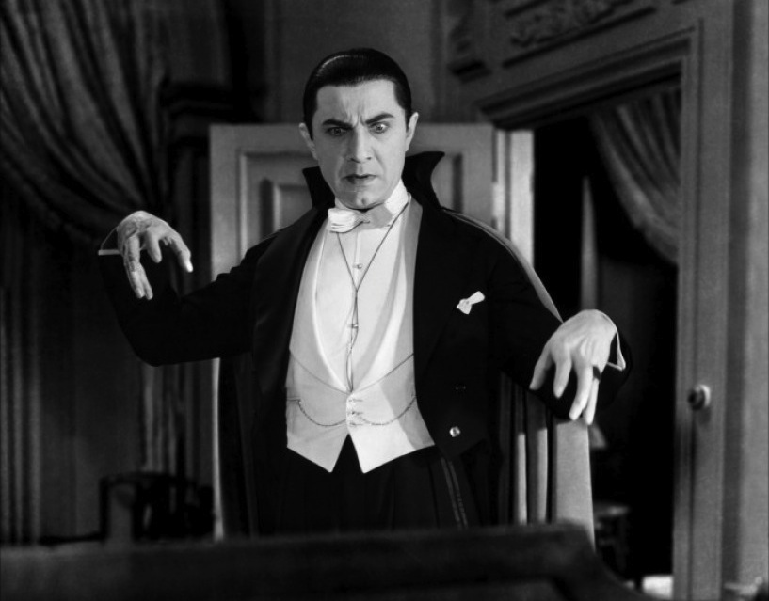

Filmadatok:
- 1931
- Horror
- 75 perc
- fekete-fehér
- amerikai
- Rendezte: Tod Browning
- forgatókönyv Bram Stoker Drakula című regényéből

- Dracula: Lugosi Béla

Lugosi Béla
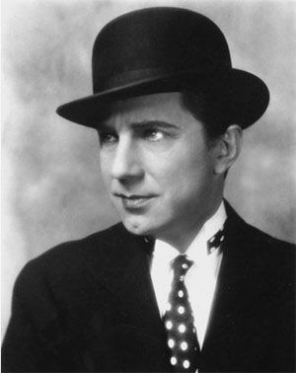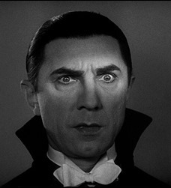

Jelenetek:
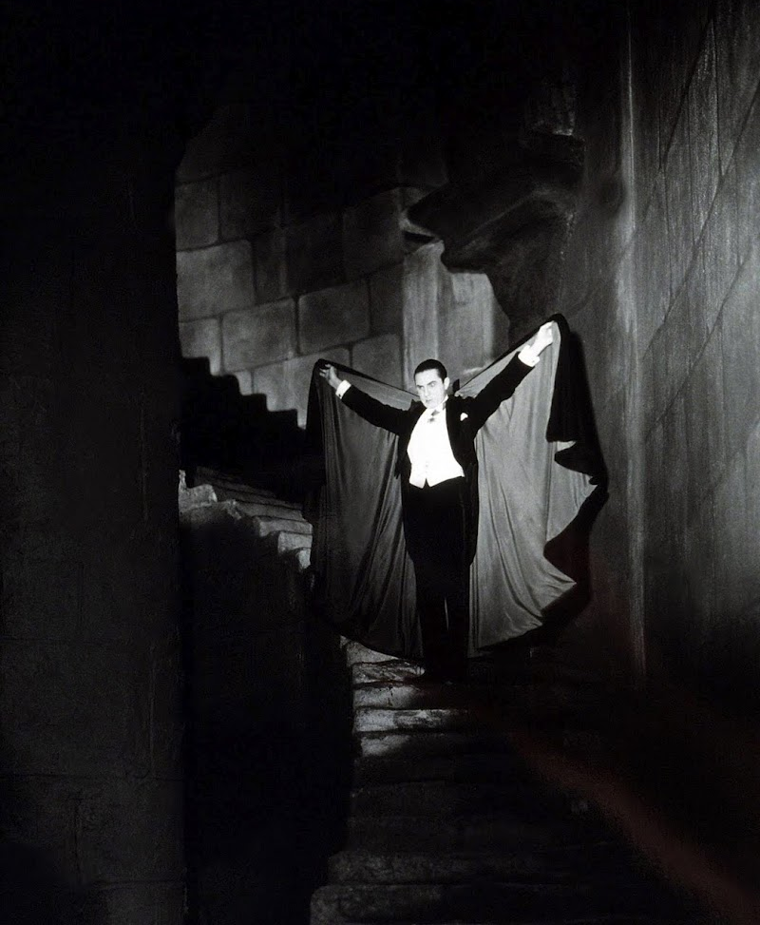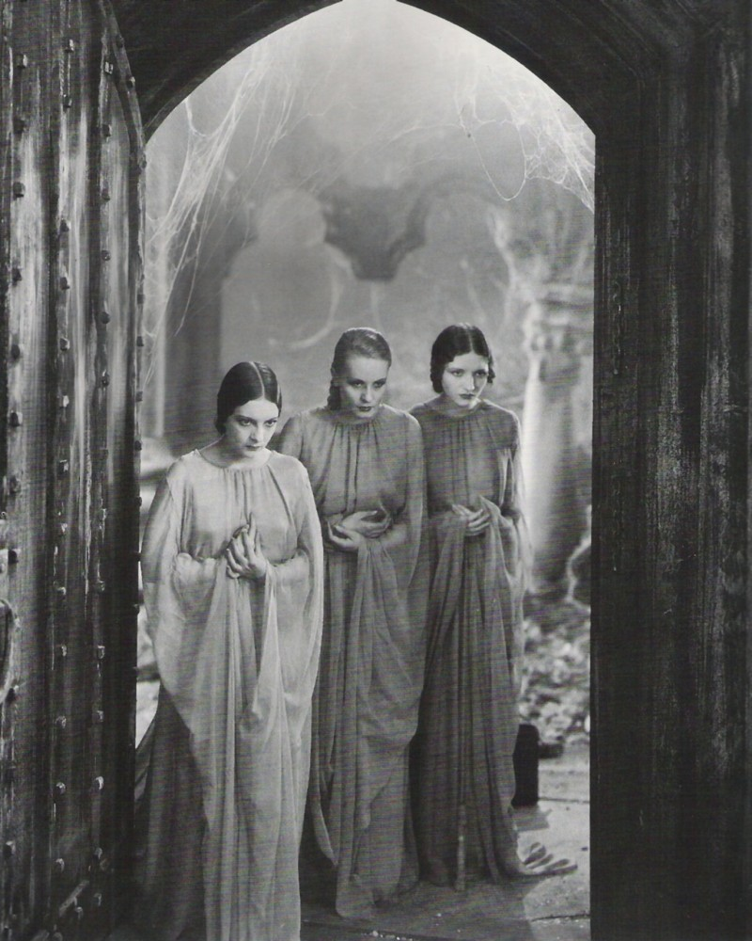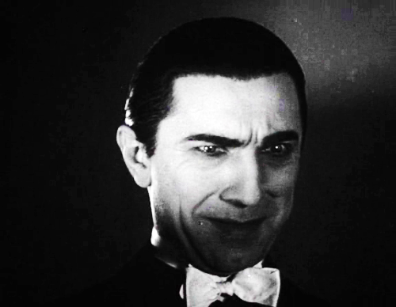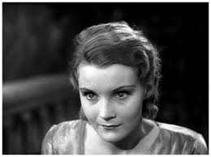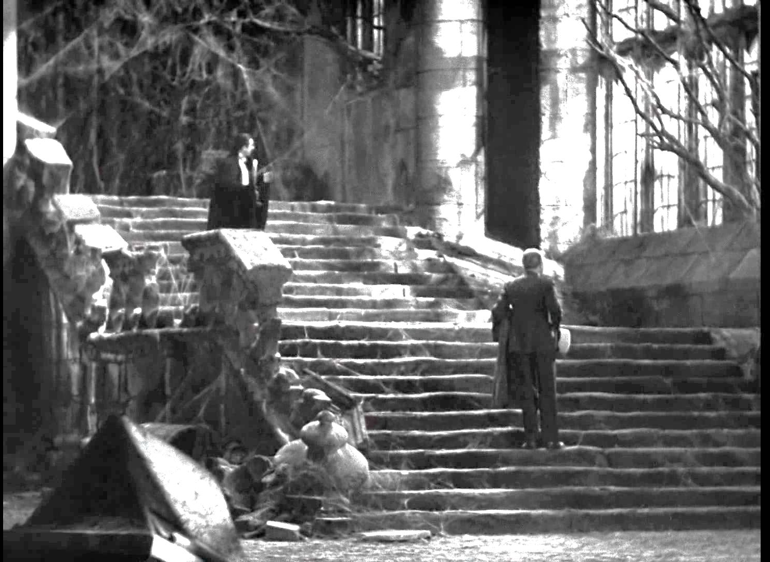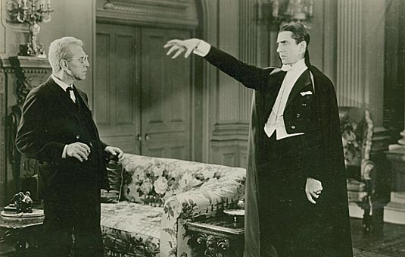

Idézetek:
The spider spinning his web for the unwary fly. The blood is the life, Mr. Renfield.

- This is very old wine. I hope you will like it.
- Aren’t you drinking?
- I never drink— wine.

Listen to them. Children of the night. What music they make!

- To die, to be really dead, that must be glorious!
- Why, Count Dracula!
- There are far worse things awaiting man than death.

The strength of the vampire is that people will not believe in him.

Come here. [Dracula raises his hand to hypnotize Van Helsing.]
Come here. [Van Helsing takes three hypnotized steps towards Dracula but soon steps back, resisting Dracula's power over him.]
Your will is strong, Van Helsing

Dracula-színészek:
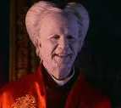 | 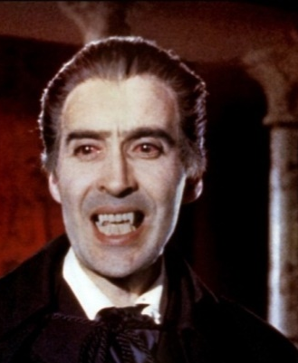
Gary Oldman | Cristopher Lee
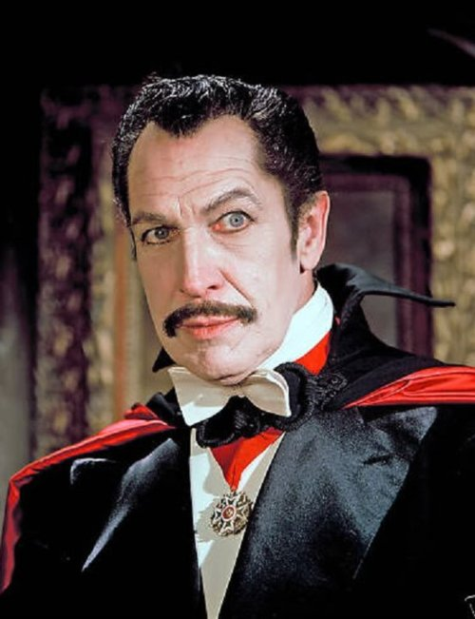 | 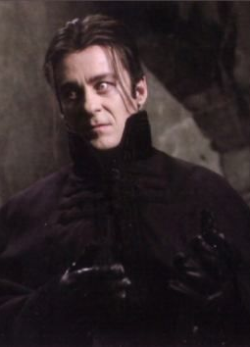
Vincent Price | Richard Roxburgh
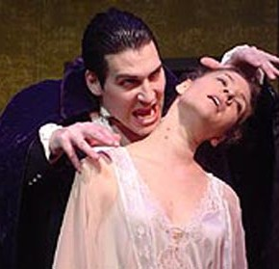 | 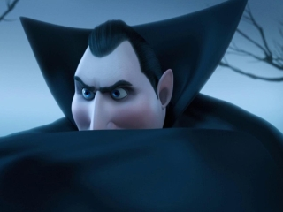
(színház) | Hotel Transylvania

